Assessment Schedule – 2012
Chemistry: Demonstrate understanding of the properties of selected organic compounds (91165)

Assessment Criteria
Achievement | Achievement with Merit | Achievement with Excellence
Demonstrate understanding involves naming and / or drawing structural formulae of selected organic compounds (no more than eight carbons in the longest chain) and giving an account of their chemical and physical properties. This requires the use of chemistry vocabulary, symbols and conventions. | Demonstrate in-depth understanding involves making and explaining links between structure, functional groups and the chemical properties of selected organic compounds. This requires explanations that use chemistry vocabulary, symbols and conventions. | Demonstrate comprehensive understanding involves elaborating, justifying, relating, evaluating, comparing and contrasting, or using links between the structure, functional groups and the chemical properties of selected organic compounds. This requires the consistent use of chemistry vocabulary, symbols and conventions.

One | Expected Coverage | Achievement | Merit | Excellence
(a) | butan-2-ol  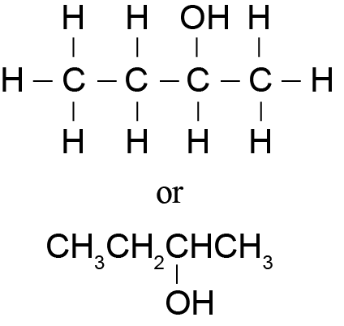  methylpropan-1-ol  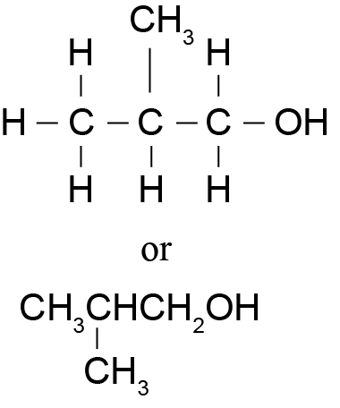  methylpropan-2-ol  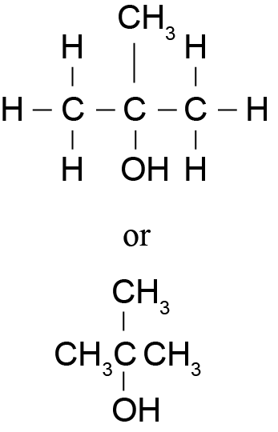 | - In (a) TWO names or structural formulae correct.  - In (b) correct reagent with condition.  - In (b) correct colour change.  - In (b) correct isomer identified.  OR  - Identifies a 1° alcohol.  - In (c) identifies one type of reaction.  - Correctly describes observation for one reaction.  - Correctly describes product for one reaction. | - In (b) correctly identifies alcohol from (a) as a 1° alcohol and links 1° alcohols to formation of carboxylic acid.  For any of the three reactions that occur in (c):  - Correctly identifies TWO types of reactions and links them to the correct observations or products.  OR  - Correctly identifies ONE type of reaction and correctly links it to the correct observations and organic product.  OR  For TWO reactions, links the correct observations to the organic products. | In (c) use of both reagents fully discussed with: appropriate reaction types described; necessary conditions given where appropriate; observations given; and correct equations.  Evaluation of the use of the reagents, e.g. MnO₄– / H⁺ reacts with only one of the substances or Br₂ requires UV light to react with the alkane.
(b)(i)  (ii)  (iii) | MnO₄– / H⁺ or Cr₂O₇^{2–} / H⁺  purple → colourless, or  orange → green  2-methylpropan-1-ol. Since it is a 1° alcohol it can be oxidised to a carboxylic acid / since the others are secondary or tertiary alcohols and can’t be oxidised to a carboxylic acid.
(c) | Either of the two reagents could be used.  Br₂ will react with both substances, but the reaction with hexane is slow and requires UV light. Permanganate will only react with pent-1-ene.  Br₂ reacts with pent-1-ene in an addition reaction. Br₂ changes colour from orange to colourless.  Reaction is:  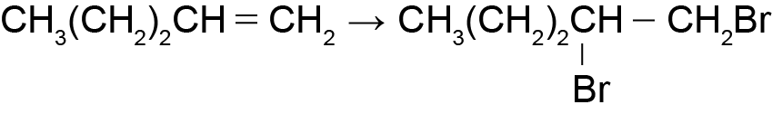  Br₂ reacts with hexane in a substitution reaction, UV light is required for the reaction / Br₂ does not react with hexane. Br₂ changes colour from orange to colourless / no colour change.  Reaction is:  CH₃(CH₂)₄CH₃ → CH₃(CH₂)₄CH₂Br  MnO₄– / H⁺ will react only with pent-1-ene. The reaction is an oxidation / addition reaction. Acidified MnO₄– changes from purple to colourless. (MnO₄– changes colour from purple to brown).  Reaction for permanganate is:  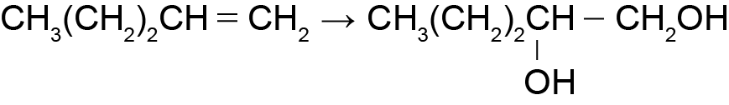

NØ | N1 | N2 | A3 | A4 | M5 | M6 | E7 | E8
No response or no relevant evidence. | 1a | 2a | 3a | 4a | 1m | 2m | e  with one minor error / minor omission / additional irrelevant information | e  with one minor error

Two | Expected Coverage |  |  |  | Achievement |  |  | Merit |  |  | Excellence
(a) | 2,2-dichloropropane  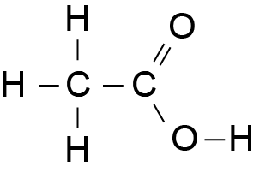  Or  CH₃COOH  5-bromo-2-methylpentanoic acid  Methanamine or aminomethane  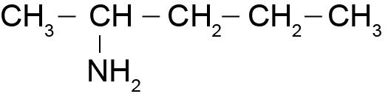 |  |  |  | - In (a) THREE names or structural formulae correct.  - In (b) butanamine turns litmus blue OR butanoic acid turns litmus red.  - In (c) acid-base reaction  OR CO₂ produced.  - Sodium salt correct.  - In (d) one type of reaction correct.  - In (d) one type of functional group / product correct. |  |  | In (d):  - For the elimination reaction forming ethene:  The type of reaction plus  THREE of:  reason, the functional group, or the organic product correct.  - For the substitution reaction forming ethanol:  The type of reaction plus  THREE of:  reason, the functional group, or the organic product correct.  - For the substitution reaction forming ethanamine:  The type of reaction plus  THREE of:  reason, the functional group, or the organic product correct. |  |  | In (d) compares and contrasts THREE reactions fully with equations.
(b) | Butanamine (aminobutane) is basic, so will turn red litmus paper blue.  Butanoic acid is acidic, so will turn blue litmus paper red.
(c)(i)  (ii)  (iii) | Acid-base / neutralisation  CO₂ gas is a product of the reaction and so bubbles of gas are given off.  CH₃CH₂CH₂COONa
(d) | Chloroethane reacts with KOH(aq) to form an alcohol in a substitution reaction; Cl is replaced by OH.  CH₃CH₂Cl → CH₃CH₂OH  Chloroethane reacts with KOH(alc) to form an alkene in an elimination reaction; H and Cl removed / HCl formed.  CH₃CH₂Cl → CH₂ = CH₂  Chloroethane reacts with NH₃(alc) to form an amine in a substitution reaction; Cl is replaced by NH₂  CH₃CH₂Cl → CH₃CH₂NH₂
NØ |  | N1 | N2 | A3 |  | A4 | M5 |  | M6 | E7 |  | E8
No response or no relevant evidence. |  | 1a | 2a | 3a |  | 4a | 1m |  | 2m | e  with ONE error |  | e  with ONE minor error

Three | Expected Coverage |  |  |  |  | Achievement |  |  |  | Merit |  | Excellence
(a)(i)  (ii)  (iii) | 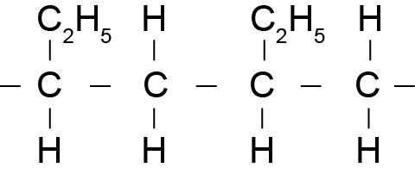  H₂ (/Pt)  PCl₃ / PCl₅ / SOCl₂ |  |  |  |  | - In (a) polymer structure is correct.  - In (a) reagent 4 (H₂) is correct.  - In (a) reagent 3 (PCl₃ / PCl₅ / SOCl₂) is correct.  - In (b) correct answer (no) with some reason.  OR  - In (b) incorrect answer (yes) however recognises requirement for double bond in geometric isomers.  - In (c) identifies major (or minor) product.  - Draws an alcohol structure. |  |  |  | - In (b) No. The carbons of the double bond need two different atoms. This has two atoms that are the same.  - For C and D explains why there are two products  OR  - Explains placement of structure in C linked to structure E. |  | In (c) correct structures with full justification for BOTH products and placement of products.
(b) | No; for a molecule to exist as geometric isomers, it must contain a double bond, and each carbon (involved in the double bond) must have two different atoms / groups attached to it. Compound A has a double bond, but the atoms attached to one carbon are both the same (two hydrogen atoms) so it does not form a geometric isomer.
(c)(i)  (ii) | 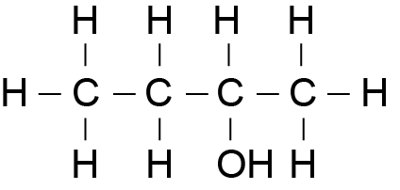  C  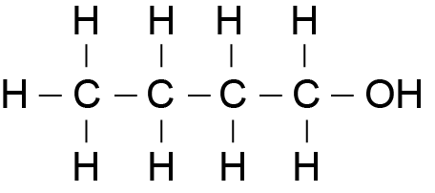  D  C is the major product and D is the minor product.  There are 2 possible products because when the double bond is broken, an H (or –OH) will bond to one C (and a –OH group (or H) will bond with the other C). The product will depend on which (C) the H (or the –OH) bond to.  C must be 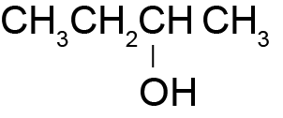since  product E is 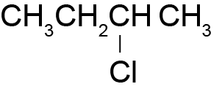i.e. both  functional groups are on the second carbon atom.  If CH₃CH₂CH₂ CH₂OH was C then E would be CH₃CH₂CH₂CH₂Cl.
NØ |  | N1 | N2 | A3 | A4 |  | M5 | M6 | E7 |  | E8
No response or no relevant evidence. |  | 1a | 2a | 3a | 4a |  | 1m | 2m | e  with one error / omission /irrelevant information, e.g. C only considered |  | e  with one minor error

Judgement Statement
 | Not Achieved | Achievement | Achievement  with Merit | Achievement  with Excellence
Score range | 0 – 7 | 8 – 14 | 15 – 19 | 20 – 24

